**Project Planning Phase**

**Project Planning Template (Product Backlog, Sprint Planning, Stories, Story points)**

|  |  |
| --- | --- |
| Date | 17 November 2022 |
| Team ID | PNT2022TMID07956 |
| Project Name | Digital Naturalist - AI Enabled tool for Biodiversity Researchers |
| Maximum Marks | 8 Marks |

**Product Backlog, Sprint Schedule, and Estimation (4 Marks)**

|  |  |  |  |  |  |  |
| --- | --- | --- | --- | --- | --- | --- |
| **Sprint** | **Functional**  **Requirement (Epic)** | **User Story Number** | **User Story / Task** | **Story Points** | **Priority** | **Team Members** |
| Sprint-1 | Modelling Phase | USN-1 | Collecting Data | 3 | High | JAGADESWARAN A |
| Sprint-1 | USN-2 | Transforming the data into machine readable format | 2 | Medium | BHUVAN KUMAR R |
| Sprint-1 | USN-3 | Building a CNN model | 5 | High | JANARTHANAN G  BHUVAN KUMAR R |
| Sprint-1 | USN-4 | Evaluating the model to check the accuracy and precision | 3 | High | JAGADESWARAN A BHUVAN KUMAR R |
| Sprint-2 | Development Phase | USN-5 | Home page Creation for the application | 1 | Low | JEEVA K  JAGADESWARAN A |
| Sprint-2 | USN-6 | Setting up facilities for user to feed the image | 2 | Medium | JEEVA K  JAGADESWARAN A |
| Sprint-2 | USN-7 | Prediction page creation – shows prediction for the user given image | 4 | Medium | BHUVAN KUMAR R |
| Sprint-2 | USN-8 | Model loading and application creation using flask | 5 | High | BHUVAN KUMAR R |
| Sprint-3 | Deployment Phase | USN-9 | Integrating UI & backend – Connecting the front end and backend using API calls | 3 | Medium | JANARTHANAN G |
| Sprint-3 | USN-10 | Cloud deployment – Deployment of application using IBM Cloud | 5 | High | JANARTHANAN G |
| Sprint-4 | Testing Phase | USN-11 | Functional testing – Checking the scalability and robustness of the application | 5 | High | JEEVA K  JAGADESWARAN A |
| Sprint-4 | USN-12 | Non-Functional testing – Checking for user acceptance and integration | 5 | High | BHUVAN KUMAR R  JAGADESWARAN A |

**Project Tracker, Velocity & Burndown Chart: (4 Marks)**

|  |  |  |  |  |  |  |
| --- | --- | --- | --- | --- | --- | --- |
| **Sprint** | **Total Story Points** | **Duration** | **Sprint Start Date** | **Sprint End Date (Planned)** | **Story Points**  **Completed (as on**  **Planned End Date)** | **Sprint Release Date (Actual)** |
| Sprint-1 | 13 | 6 Days | 24 Oct 2022 | 29 Oct 2022 | 13 | 29 Oct 2022 |
| Sprint-2 | 12 | 6 Days | 31 Oct 2022 | 05 Nov 2022 | 12 | 05 Nov 2022 |
| Sprint-3 | 8 | 6 Days | 07 Nov 2022 | 12 Nov 2022 | 8 | 12 Nov 2022 |
| Sprint-4 | 10 | 6 Days | 14 Nov 2022 | 19 Nov 2022 | 10 | 19 Nov 2022 |

**Velocity:**

Average Velocity = 61/24 = 2.51

JANARTHANAN G **Burndown Chart:**

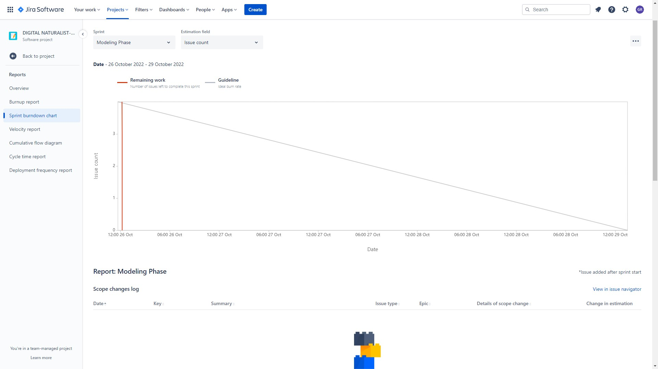

**Roadmap:**

